Shadow paging in DBMS

This is the method where all the transactions are executed in the primary memory or the shadow copy of database. Once all the transactions completely executed, it will be updated to the database. Hence, if there is any failure in the middle of transaction, it will not be reflected in the database. Database will be updated after all the transaction is complete.
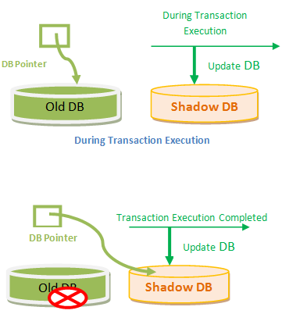

A database pointer will be always pointing to the consistent copy of the database, and copy of the database is used by transactions to update. Once all the transactions are complete, the DB pointer is modified to point to new copy of DB, and old copy is deleted. If there is any failure during the transaction, the pointer will be still pointing to old copy of database, and shadow database will be deleted. If the transactions are complete then the pointer is changed to point to shadow DB, and old DB is deleted.
As we can see in above diagram, the DB pointer is always pointing to consistent and stable database. This mechanism assumes that there will not be any disk failure and only one transaction executing at a time so that the shadow DB can hold the data for that transaction. It is useful if the DB is comparatively small because shadow DB consumes same memory space as the actual DB. Hence it is not efficient for huge DBs. In addition, it cannot handle concurrent execution of transactions. It is suitable for one transaction at a time.

Shadow paging is a technique for providing atomicity and durability in database systems.
Shadow paging considers:
- The database is partitioned into fixed-length blocks referred to as PAGES.
- Page table has n entries – one for each database page.
- Each contain pointer to a page on disk (1 to 1st page on database and so on…).
The idea is to maintain 2 page tables during the life of transaction.
- The current page table
- The shadow page table
When transaction starts, both page tables are identical
- The shadow page table is never changed over the duration of the transaction.
- The current page table may be changed when a transaction performs a write operation.
- All input and output operations use the current page table to locate database pages on disk.
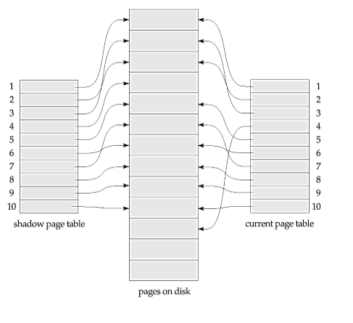
Advantages:
• No Overhead for writing log records.
• No Undo / No Redo algorithm.
• Recovery is faster.
Disadvantages:
- Hard to extend algorithm to allow transaction to run concurrently.
- Commit overhead- The commit of a single transaction using shadow paging requires multiple blocks to be output -- the current page table, the actual data and the disk address of the current page table. Log-based schemes need to output only the log records.
- Data fragmentation- Shadow paging causes database pages to change locations (therefore, no longer contiguous.
- Garbage collection- Each time that a transaction commits, the database pages containing the old version of data changed by the transactions must become inaccessible. Such pages are considered to be garbage since they are not part of the free space and do not contain any usable information. Periodically it is necessary to find all of the garbage pages and add them to the list of free pages. This process is called garbage collection and imposes additional overhead and complexity on the system.

